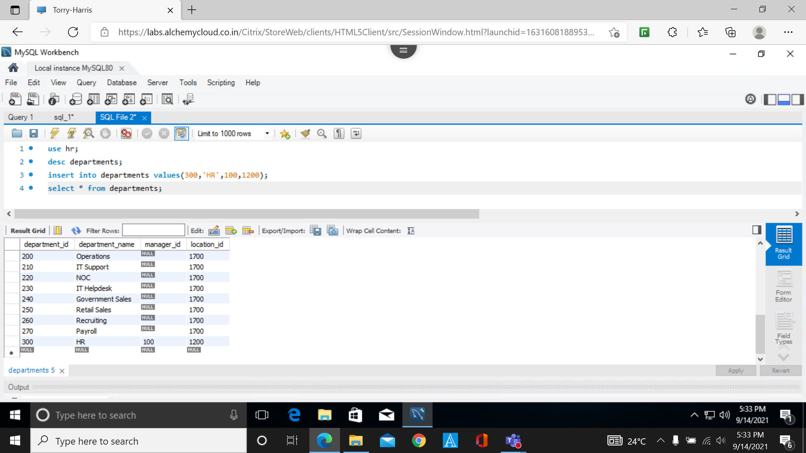

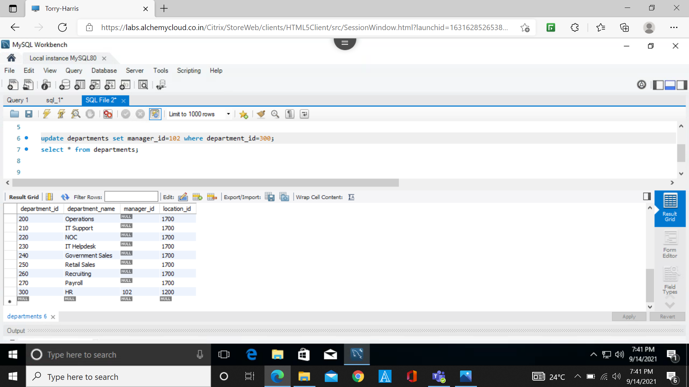

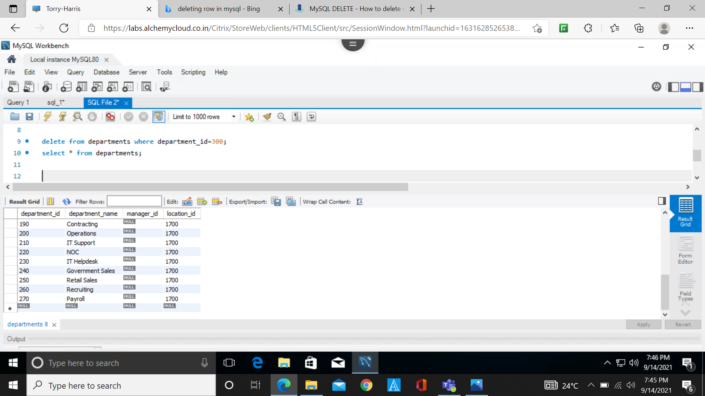

Inserting a row from one table to another

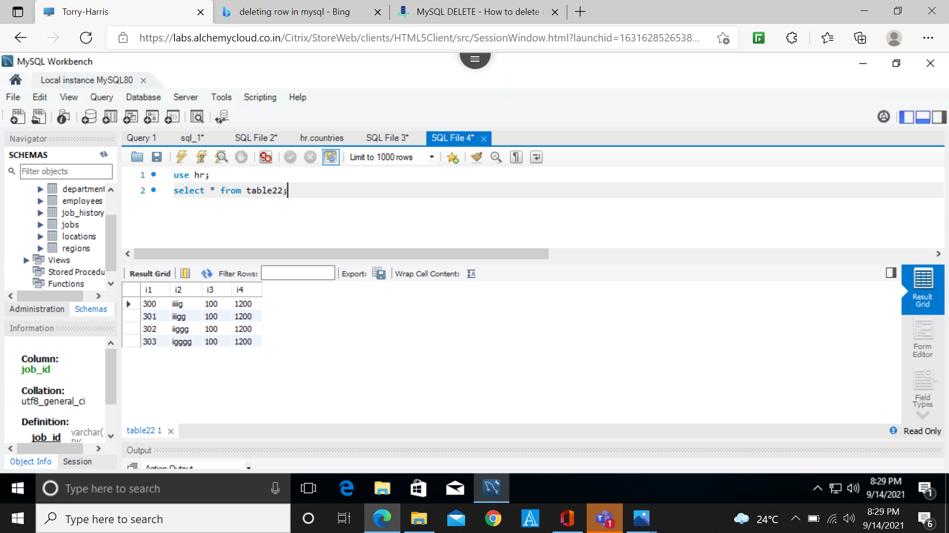

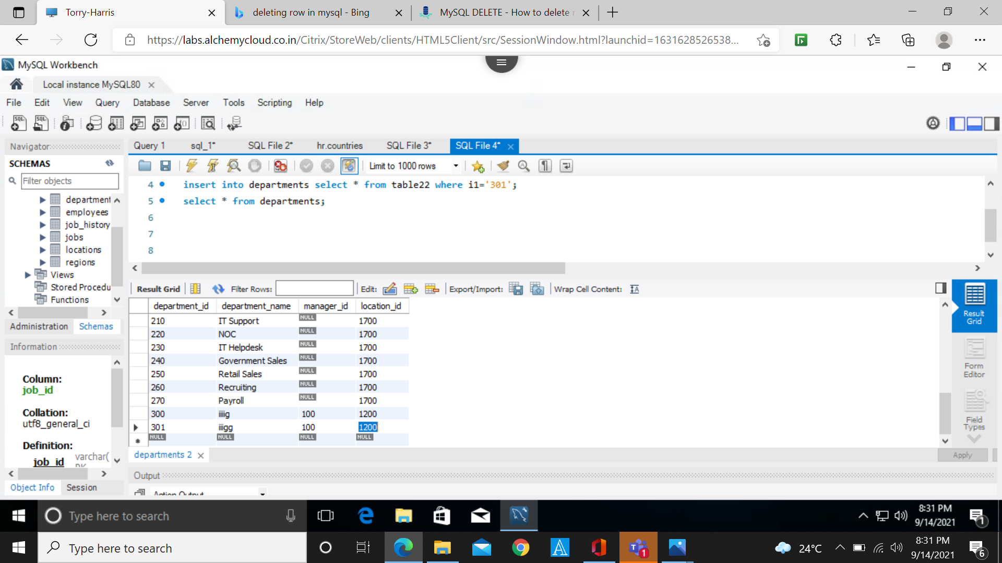

**TEAM 5 - SELECT, UPDATE and DELETE Commands**

**use hr;**

**desc departments;**

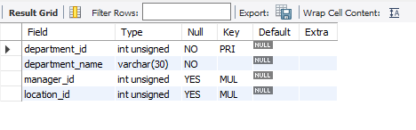

**select * from departments :**

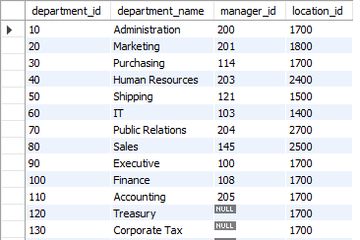

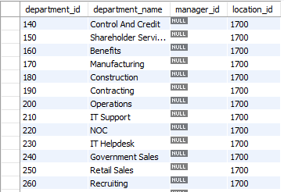



**#INSERTING A NEW RECORD( ROW ) TO THE TABLE :**

**insert into departments values(300, ‘HR’, 100, 1200);**

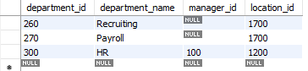

**#UPDATING THE TABLE VALUES :**

**update departments set manager_id=102 where department_id=300;**

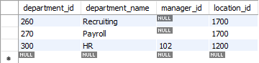

**#DELETING A RECORD FROM THE TABLE :**

**delete from departments where department_id=300;**

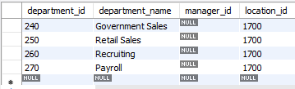

**#ADDING A NEW COLUMN TO THE TABLE :**

**alter table departments add(country_name VARCHAR(5));**

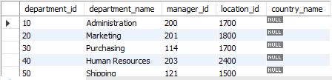

**#DELETING A COLUMN FROM THE TABLE :**

**alter table departments drop column country_name;**

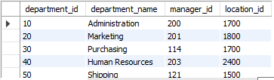

All Commands

use hr;  
 desc departments;  
 select * from departments;

#updating the table values   
update departments set manager_id=102 where department_id=300;

#inserting a new row to the table  
 insert into departments values(300,'HR',100,1200,'IN');

#adding a new column to the table   
alter table departments add(country_name VARCHAR(5));

#deleting a row form the table  
 delete from departments where department_id=300;

#deleting a column from a table  
 alter table departments drop column country_name;